

trilioVault™

Quick Start Deployment Guide

Table of Contents

Packaging 3

Deployment Model 3

Best Practice Guidelines for trilioVault Deployment 4

Minimum Requirements 4

Installing trilioVault Appliance on VMware vCenter 4

Configure trilioVault™ Appliance 9

# Packaging

trilioVault is a Backup and Recovery solution from Trilio Data for supported NoSQL and RDBMS environments. It is deployed as a software appliance in a VMware environment. It is distributed to customers as an OVF file. The deployment of the trilioVault appliance is via this OVF file using native VMware tools.

# Deployment Model

trilioVault OVF images is instantiated as trilioVault controller nodes running on top of ESX servers. You can have one or more of these controller nodes deployed for scalability purposes as shown in the Figure 1.0. The trilioVault controller nodes are responsible to take full or incremental snapshots of the application workload. An application workload can consist of one or more virtual machines that need to be protected as a group. The snapshots can be stored on local virtual disk or a NFS mount point.

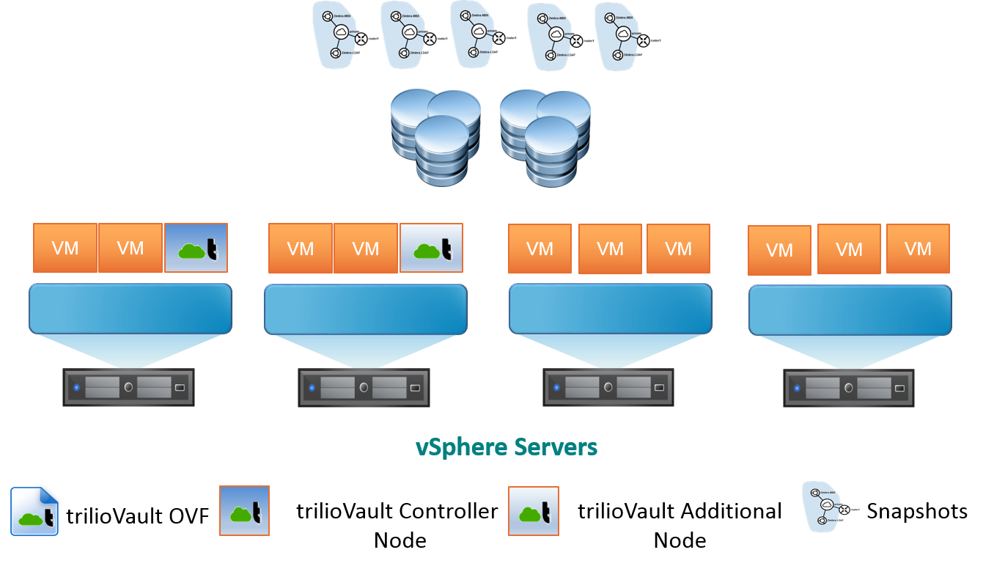

Figure **1.0**

# Best Practice Guidelines for trilioVault Deployment

1. Assess storage needs for storing Application Backups by using the trilioVault calculator. The calculator can estimate the backup storage requirement per application. Aggregate the storage requirement for all the application workloads that need to be protected. Use this storage space requirement to create a local virtual disk or create a NFS file system.
2. It is recommended that if more than one application workload is to be backed up then have at least two or more trilioVault controller nodes for the deployment.
3. Each trilioVault controller node can be configured for two network interfaces. One is for the network on which VMware vCenter is on and the other one is for the application network.
4. If you are using multiple trilioVault controllers then you should use a NFS file system for storing the backups.

# Minimum Requirements

VMWare vSphere®: ESXi 5.1 Update 2 or above

VMWare® vCenter™ Server: vCenter Server 5.1 Update 2 or above

trilioVault Appliance: Storage: 1TB free space

Memory: 16GB

vCPUS: 4

MongoDB™: v2.4 or above

Apache Cassandra™: v2.0 or above

Support for DataStax Enterprise v4.5 or above

PostGreSQL™: v9.3 or above

MySQL™: v2.1 or above

# Installing trilioVault Appliance on VMware vCenter

This section discusses how to configure the trilioVault appliance on VMware using a vSphere client.

1. Copy the trilioVault OVF file to the host where you are running vSphere Client.
2. Deploy VM using OVF template method as shown below in Figure 2.0

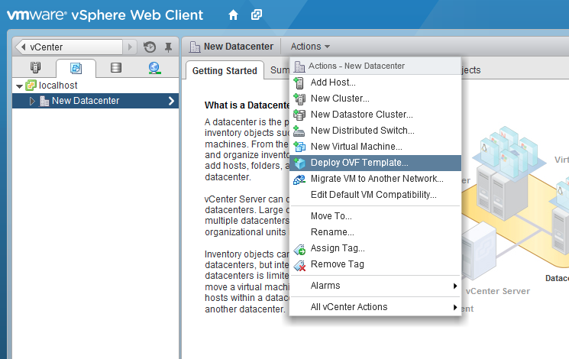

Figure **2.0**

1. Specify the source location (Figure 3.0) of the OVF file and click **Next**

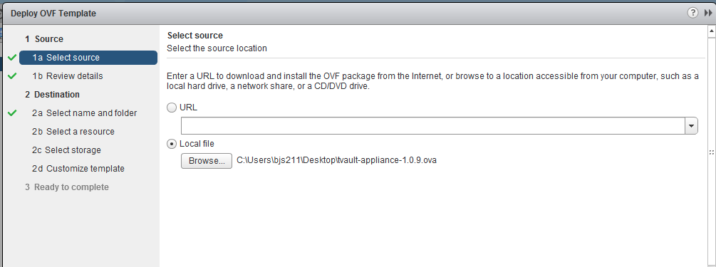

Figure **3.0**

1. Provide the name (Figure 4.0) for the trilioVault appliance and select the destination folder to run a specified host, cluster or resource pool to run the appliance.

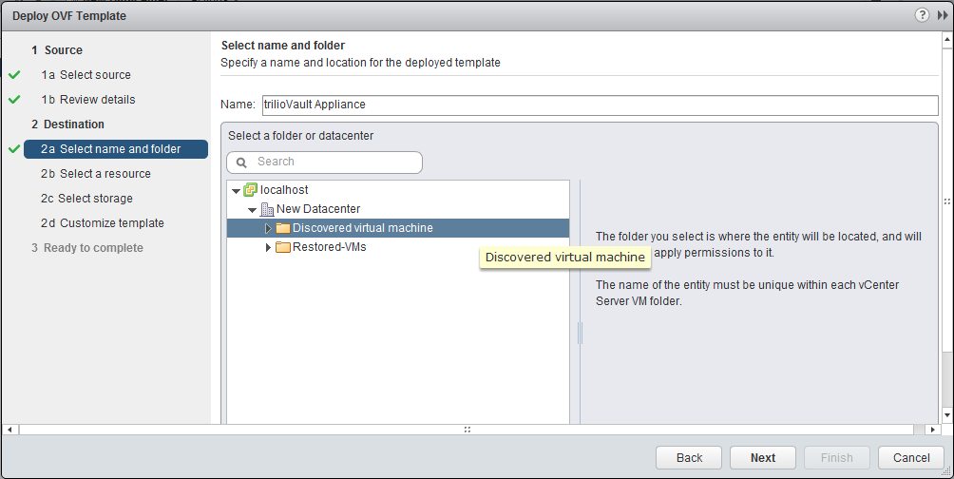

Figure **4.0**

Select a Cluster (Figure 5.0) and designate an ESX host to run the trilioVault appliance.

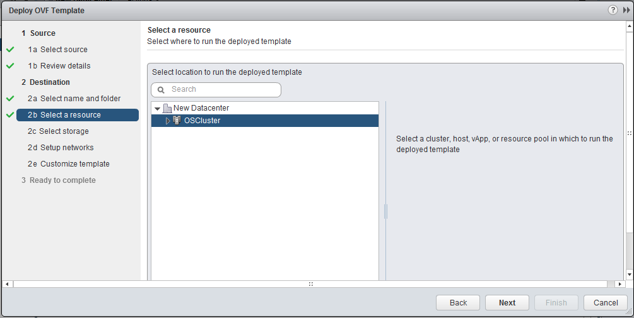

Figure **5.0**

1. Select a datastore (Figure 6.0) to store the deployed OVF template and choose the disk format to store the virtual disks for the trilioVault virtual machine, and click **Next**.

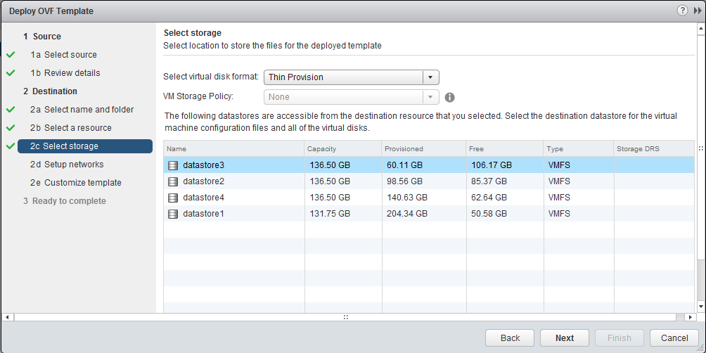

Figure **6.0**

1. Configure and choose one of the networks (Figure 7.0) that the OVF template should use.

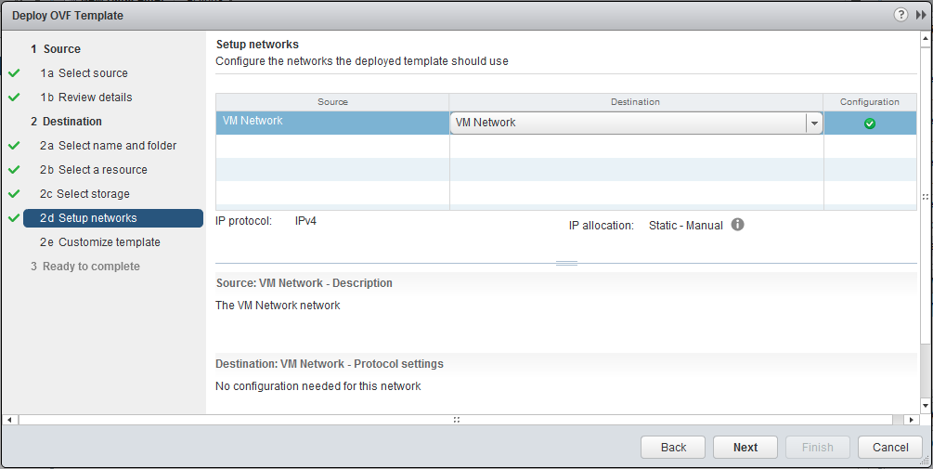

Figure **7.0**

1. Set the user-configurable (Figure 8.0) network interface settings (IP address, Netmask and Gateway) and click **Next**.

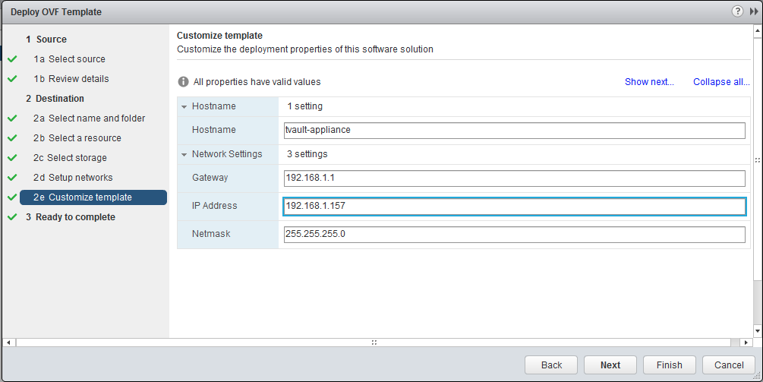

Figure **8.0**

1. Review your settings (Figure 9.0) and click Finish.

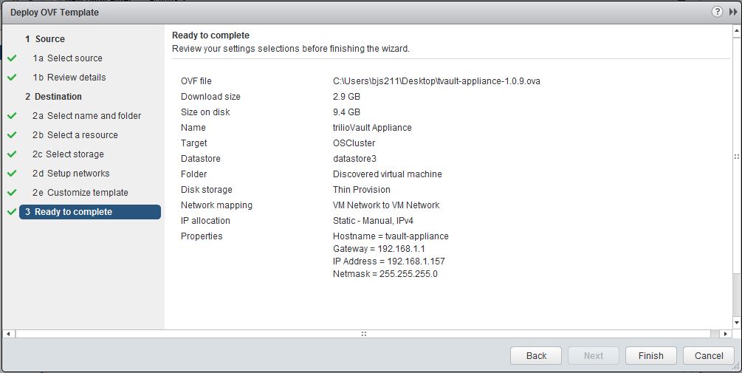

Figure **9.0**

This will then create the trilioVault virtual machine. Once the virtual machine is powered on, it is ready to be configured via the web browser.

# Configure trilioVault™ Appliance

Once the VM is successfully created, power on the virtual appliance. After the VM is up and running, point your web browser to the trilioVault appliance IP address. The landing page contains detailed instructions on how to configure the appliance for your environment. Click on the link to configure the appliance as shown in Figure 10. The default user name is ‘admin’ and the password is ‘password’. After this you will be prompted to change the password.

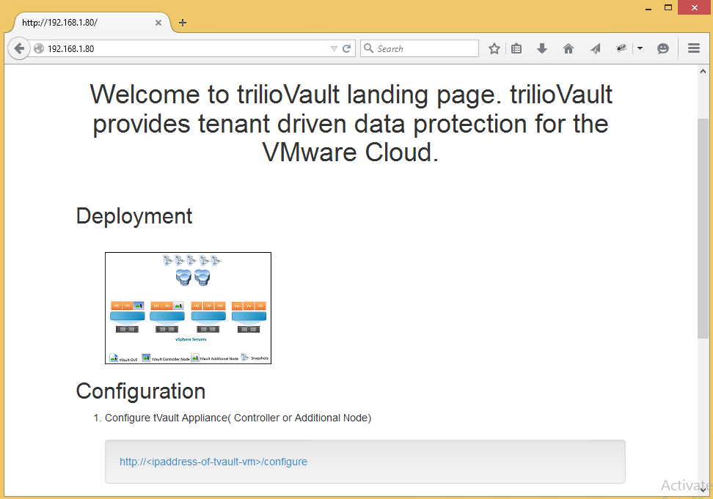

Figure **10.0**

Enter the following information about your vCenter. Optionally, you can enter the DNS server name for trilioVault to lookup any hostnames. DNS entry is useful for creating workloads such as MongoDB, where the hosts need to be looked up based on the host names of the MongoDB configuration.

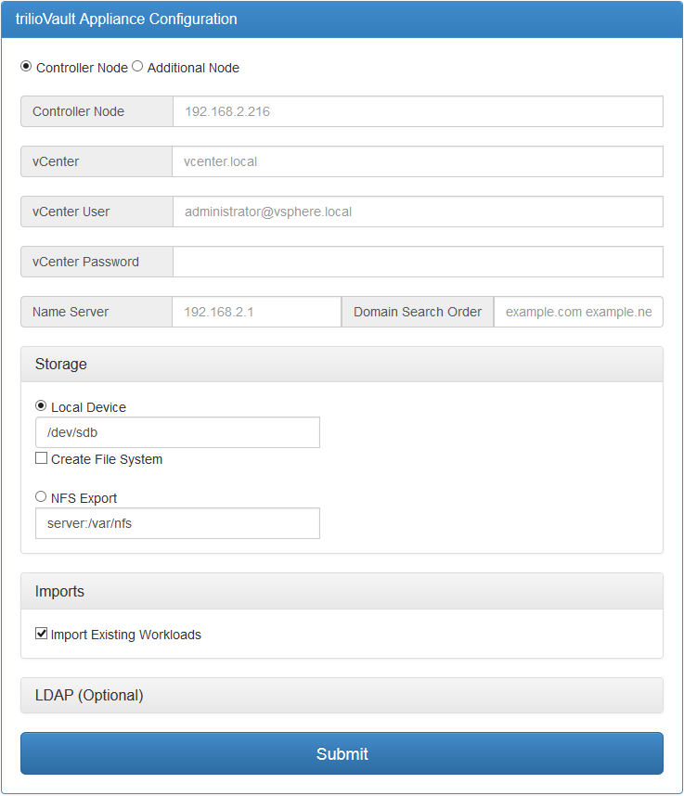

Figure **11.0**

Note: If you plan to create multi node tVault installation, a name server must be configured with the host records for all the tVault nodes. Additionally, you must use choose the NFS storage option.

trilioVault is a distributed appliance. That means you can “spin up” as many VMs as you want and trilioVault will still function as one service. A multi-VMs solution can be used for high availability and load distribution. Start with controller node, which is a primary node and then add additional nodes as needed.

**trilioVault Configuration Inputs:**

|  |  |
| --- | --- |
| Controller Node/Additional Node | Configure a Controller node first before configuring the additional nodes |
| Controller Node | Provide the static IP address of the controller node |
| vCenter | Provide the hostname or the IP address of the vCenter Server |
| vCenter User | vCenter Username with permissions to backup and restore ( see appendix A) |
| vCenter Password | Password for the vCenter User |
| Storage | You can choose local or NFS storage as the media to store trilio’s VAST snapshots |

**Optional LDAP Configuration Inputs:**

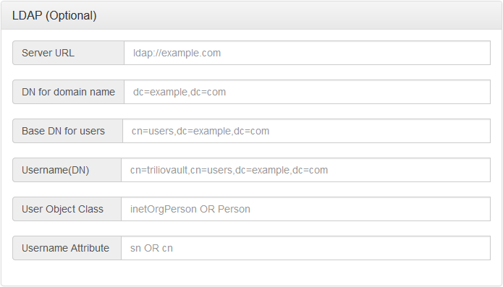

Figure **12.0**

|  |  |
| --- | --- |
| Server URL | URL of the LDAP Server  ldap://example.com |
| DN for domain name | Distinguished name of the domain  dc=example,dc=com |
| Base DN for users | Base domain name for users cn=users,dc=example,dc=com |
| Username(DN) | Distinguished name of the vCenter User configured above.  cn=trilioVault,cn=users,dc=example,dc=com |
| User Object Class | Object Class of User in the LDAP Server  inetOrgPerson OR Person |
| Username Attribute | Attribute for the name property of an User in LDAP server  sn OR cn |

**Optional NameServer Configuration Inputs:**

Enter name server information for trilioVault to lookup hostnames. This enables trilioVault to lookup, create and manage workloads such as MongoDB, where the nodes of the workload will be looked up using hostnames.

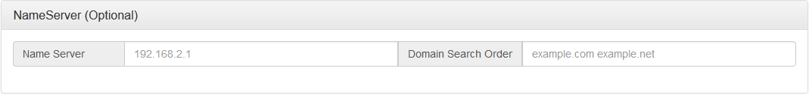

Figure **13.0**

|  |  |
| --- | --- |
| Name Server | IP address of the name server |
| Domain Search Order | Domain Search Order  example.com example.net |

Once you provide the configuration inputs. Click on “Submit”. When submitted, the configurator will go through sequence of steps to configure the appliance as shown in Figure 14.

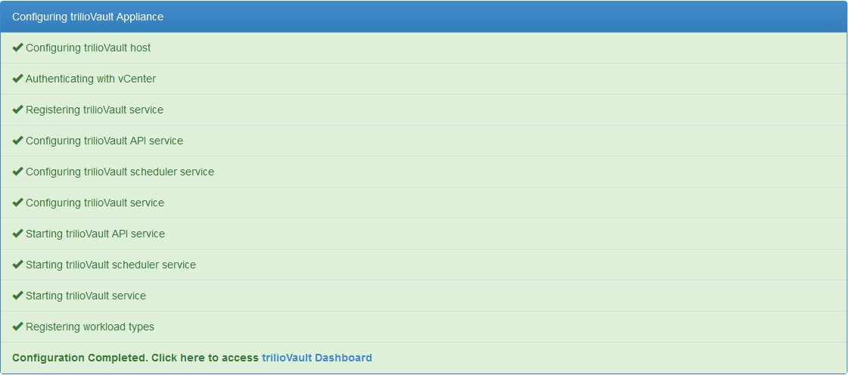

Figure **14.0**

NOTE: If there are any errors, go back and check the previous page, fix any issues and then submit. The configurator is an idempotent process, which means you can run any number of times you wish without destroying anything. However you rarely need to run the configurator more than once. Once it is properly configured). At this point, the trilioVault is ready to use.